March | 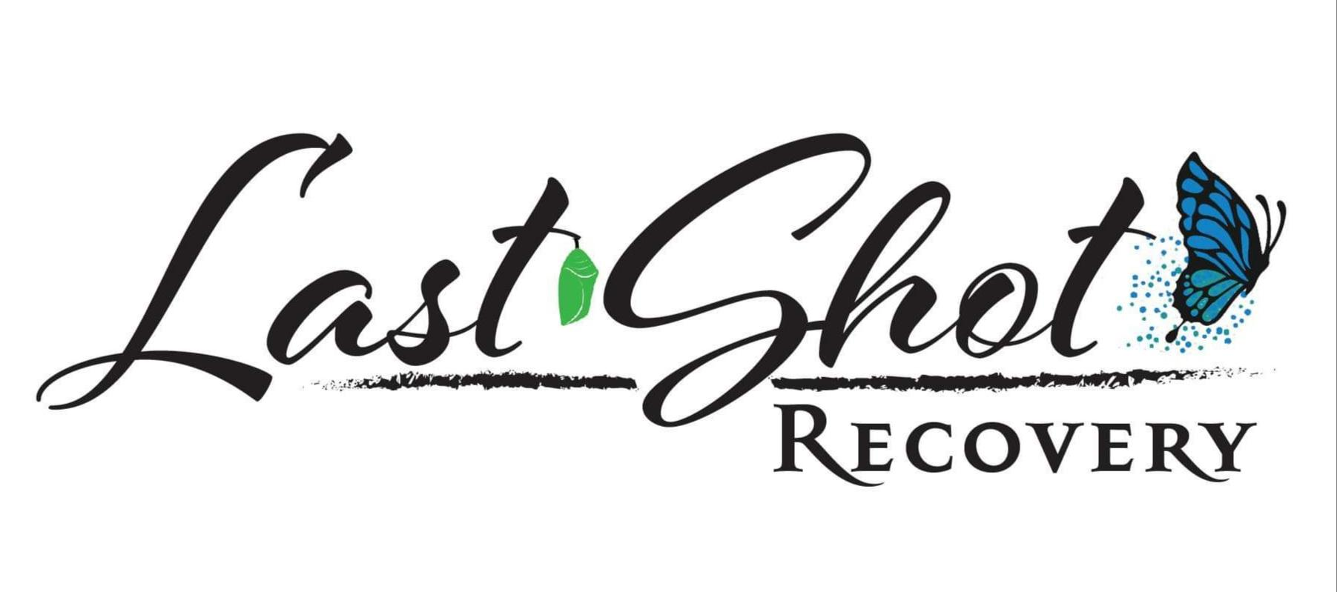
Meetings for the month | 2021
Sunday | Monday | Tuesday | Wednesday | Thursday | Friday | Saturday
 | 1 | 2 | 3 | 4 | 5 | 6
 | All Recovery  6:30-7:30PM |  | Crystal Meth Anonymous  7-8PM
7 | 8 | 9 | 10 | 11 | 12 | 13
 | All Recovery  6:30-7:30PM |  | Crystal Meth Anonymous  7-8PM
14 | 15 | 16 | 17 | 18 | 19 | 20
 | All Recovery  6:30-7:30PM |  | Crystal Meth Anonymous  7-8PM
21 | 22 | 23 | 24 | 25 | 26 | 27
 | All Recovery  6:30-7:30PM |  | Crystal Meth Anonymous  7-8PM
28 | 29 | 30 | 31
 | All Recovery  6:30-7:30PM |  | Crystal Meth Anonymous  7-8PM | 415 Chestnut Street  Lafayette, GA 30728
 |  |  |  | www.lastshotrecovery.org

